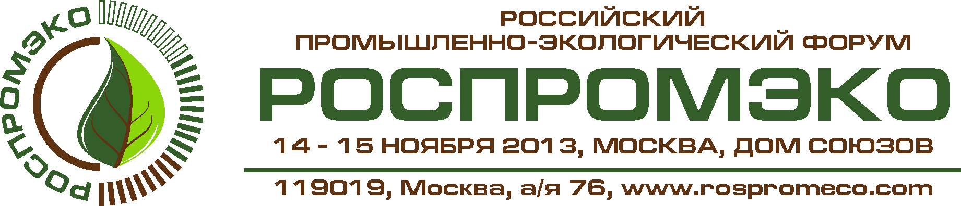

Please fill in and send the accreditation form to 08 novemder 2013 in electronic form на e-mail: pr@iprr.ru or pr@mief-tek.com

First name and surname
Name of organization
Mass media type (TV, magazine, journal and etc.)
Position
Country, city
Editorial Board Address
Phone
Fax
e-mail, web-site
Equipment
Mark the event which You want to participate* |  | Plenary session: «Russian environmental policy within the sustainable development aspect»
Mark the event which You want to participate* |  | Second Plenary Session: «Russian environmental movement "Green Russia»
Mark the event which You want to participate* |  | Round table: «On the Russian Federation's international environmental commitments»
Mark the event which You want to participate* |  | Round table: «Production and consumption waste issue: problems and solutions»
Mark the event which You want to participate* |  | Round table: «Public organizations' role in the formation of ecological thinking and culture»
Mark the event which You want to participate* |  | International conference «Processing of oil waste and reclamation of oil contaminated land: problems and solutions»
Mark the event which You want to participate* |  | Round table: «Social and ecological business responsibility in order to reduce the environmental pollution risk and biological diversity loss»

ATTENTION:
Information must be ONLY in electronic format:
Fax copies and copies, written by hand, are not accepted!

Contact person: Olga Stolyarova, p. +7(495) 664-24-18

